PENETRATION TESTING REPORT
FOOTPRINTING & NETWORK SCANNING PHASES
W2-PM-FINAL | CYBERSECURITY | NETWORKWALKS

Pentester Name  (Cybersecurity Professional) | Kwakyewa Teming-Amoako
Program/Batch | B083-Networkwalks
Date | 17 Sept. 2026
Modules completed | W2-PM1 (Multiple Kali Tools)  W2-PM5 (Zenmap Scanning)
Client/Target | 1. Networkwalks (secured written permission already)  2. My own local LAN Network
Permission secured from client? | Yes
Phases covered | Phase 1: Reconnaissance & Footprinting  Phase 2: Scanning & Network Discovery  Phase 3-5: In Progress

1. Liability Disclaimer
I have performed these activities only on the systems & devices where I had secured written permission or the devices/systems that I own myself. All these materials are for education and research purpose only. Do not use anything from here to break the law. The instructor, the authors and Networkwalks are not responsible for what you do with this knowledge. Every action you take is your own responsibility. Misuse can lead to criminal charges, heavy fines, loss of your job and a permanent record. In most countries unauthorised access is a crime even when nothing is damaged.

2. Introduction
For Week 2 of my Networkwalks internship, I put together this report to walk through two practical modules: footprinting the networkwalks.com domain using Kali Linux (W2-PM1) and mapping out my own local network with Zenmap (W2-PM5). Doing these back-to-back really highlights how an assessment flows—starting with passive intelligence gathering on public-facing targets and then moving to active host discovery on a local subnet.

All the footprinting commands were run in Kali Linux, while the network scanning was handled from a Windows PC. Throughout the report, every step includes the exact command I used, the actual results I saw, screenshot evidence, and a quick breakdown of why that specific finding matters from an attacker's point of view.

3. Tools Used
The table below lists each tool used in this report and its purpose.
Tool | Purpose
Kali Linux & Windows | Operating systems used for reconnaissance activities
WHOIS | Find domain registration details (owner, dates, name servers).
whatweb | Fingerprint web technologies (server, CMS, plugins, IP).
nslookup | Resolve the domain name to its IP address using DNS.
curl -I | Read the HTTP response headers of the website.
wafw00f | Detect whether a Web Application Firewall protects the site.
dnsrecon | Enumerate all DNS records (NS, MX, SPF, TXT, SRV).
Zenmap (Nmap GUI) | Scan the local subnet to find live hosts, IPs and MAC addresses.
Windows CMD | Local IP and MAC address identification

4. Activities Performed

4.1 Footprinting & Reconnaissance

For the footprinting phase of this project, I performed reconnaissance against the networkwalks.com domain using six different Kali Linux tools—WHOIS, WhatWeb, Nslookup, Curl, Wafw00f, and DNSRecon—with each one helping me gather a unique piece of the puzzle.

- WHOIS: First, I ran WHOIS to look up the domain's public registration details and identify its name servers, which gave me a quick look at the underlying hosting setup and domain lifecycle.

- WhatWeb: Next, I used WhatWeb to fingerprint the website's technologies. This revealed that the site runs on WordPress (specifically version 7.0.4) along with the WP Download Manager plugin (version 3.3.58), exposing key software details right off the bat.

- Nslookup: Using Nslookup, I resolved the target domain name into its direct IP address (192.232.216.135), which is a crucial step for setting up direct infrastructure mapping.

- Curl: I then used Curl with the -I option to check the HTTP response headers. This not only revealed server and caching details but also exposed the WordPress REST API endpoint at /wp-json/.

- Wafw00f: To check for defensive measures, I ran Wafw00f, which successfully identified a Web Application Firewall in use: ModSecurity (SpiderLabs).

- DNSRecon: Finally, I used DNSRecon to perform a deep enumeration of the domain's DNS records. This pulled together a comprehensive profile covering name servers, mail servers, SPF/TXT records, service records, and even the underlying BIND DNS software version.

4.2 Network Scanning with Zenmap
For the second activity, I used Zenmap to run network discovery on my local network. Following the practical steps, my goals were to find my local IP and subnet, discover live hosts, capture their IP and MAC addresses, and generate a visual network topology.

- Network Identification: I started by running the Windows ipconfig command to check my local IP address and LAN subnet. (I set this up by connecting through my phone's personal hotspot instead of a traditional home router. Because of this, my network used a much smaller address range than the standard example provided in the practical guidelines.)

- Host Discovery: Once I had those details, I plugged the subnet directly into Zenmap and ran a Ping Scan to quickly track down all active hosts sharing the network with me.
The example results provided in the practical identified two live hosts:
- 172.20.10.1
- 172.20.10.9
The example results also included two MAC addresses.
After completing the scan, I opened the Topology section in Zenmap, enabled the legend and saved the network topology in PDF format as required by the practical task.

5. Risk Analysis / Impact
Based on the information collected during the footprinting and network scanning activities, I identified the following potential risks.
# | Risk / Finding | Evidence / Observation | Potential Impact | Risk Level
1 | Web technology information exposed | WhatWeb identified WordPress and WP Download Manager | Attackers may use exposed technology/version information to identify software requiring further security review | ● Medium
2 | Server IP address identifiable | Nslookup resolved the domain to 192.232.216.135 | Provides information about the network location of the web service | ● Low
3 | HTTP technical information exposed | Curl returned HTTP response headers and exposed /wp-json/ | May assist technology fingerprinting and further enumeration | ● Low
4 | WAF technology identifiable | Wafw00f identified ModSecurity (SpiderLabs) | Reveals information about the web application’s security architecture | ● Low
5 | DNS infrastructure information exposed | DNSRecon identified DNS, mail and service-related records | DNS information can help build a broader infrastructure profile | ● Medium
6 | Multiple live hosts visible on local network | Zenmap identified two live hosts in the example network | Unknown or unauthorized devices may potentially be present on a network | ● Medium

Risk level key: ● Critical ● Medium ● Low
It is important to note that the risks listed above are simply observations gathered during the footprinting and scanning exercises, rather than confirmed vulnerabilities.

Because these two modules focused strictly on information gathering and host discovery without any active exploitation or vulnerability validation, the mere presence of data—such as software versions, IP addresses, or DNS records—does not inherently mean the system is vulnerable. To confirm whether any actual vulnerabilities exist, further authorised security testing would be necessary.

6. Recommendations

Based on what was uncovered during these exercises, here are a few practical security recommendations to help tighten up the environment:

- Keep an Eye on Public Tech Exposure: Organisations should regularly review what kind of details about their web stack, CMS, and plugins are visible to the outside world.

- Stay on Top of Software Updates: CMS platforms, plugins, and web technologies need to be patched consistently and checked against current security advisories.

- Tidy Up HTTP Headers: It’s worth reviewing HTTP response headers to make sure the server isn't accidentally broadcasting unnecessary technical information.

- Audit DNS Records Periodically: Regularly check public DNS records to ensure only necessary services and information are exposed to the internet.

- Tune and Monitor the WAF: Since ModSecurity is already in place and doing a great job blocking naive scans, keep it enabled, monitored, and properly configured.

- Run Regular Internal Scans: Organisations should periodically scan their own networks to maintain a clear picture of active devices.

- Investigate Unknown Devices: Any unexpected device that pops up during a network scan should be looked into and verified right away.

- Keep Network Documentation Fresh: Make sure network topologies and asset inventories are documented and updated regularly so nothing slips through the cracks.

- Always Secure Proper Authorisation: Reconnaissance and testing should only ever be performed on systems and networks where you have explicit, written permission.

7. Conclusion

During Week 2 of my Cybersecurity & Ethical Hacking internship, I completed practical activities covering footprinting, reconnaissance, and network scanning.
In the footprinting activity, I used six Kali Linux tools to collect information about the target domain. I learned how WHOIS can provide domain registration details, WhatWeb can identify web technologies, Nslookup can resolve domain names, Curl can inspect HTTP headers, Wafw00f can identify a WAF, and DNSRecon can uncover deeper DNS infrastructure.
In the network scanning activity, I used Zenmap to identify my local network configuration—navigating a non-standard subnet via my mobile hotspot—and discovered active hosts. I also collected IP and MAC address details and mapped out a visual network topology.
These exercises really highlighted for me just how vital information gathering is in cybersecurity. Even before attempting to interact with or test a system, a security professional can learn a tremendous amount about an environment simply by carefully analyzing publicly available data and network responses.
I also learned that technical findings need to be documented clearly and thoroughly. A great cybersecurity report should seamlessly explain what was performed, what was discovered, what the observation means, what risks might be attached to it, and what practical steps can be taken to reduce those risks.
Finally, these modules reinforced the golden rule that reconnaissance and scanning must always be performed strictly within an authorized scope. These activities were completed responsibly as part of my assigned educational cybersecurity lab, laying a solid foundation for everything ahead.

8. Evidences Collected

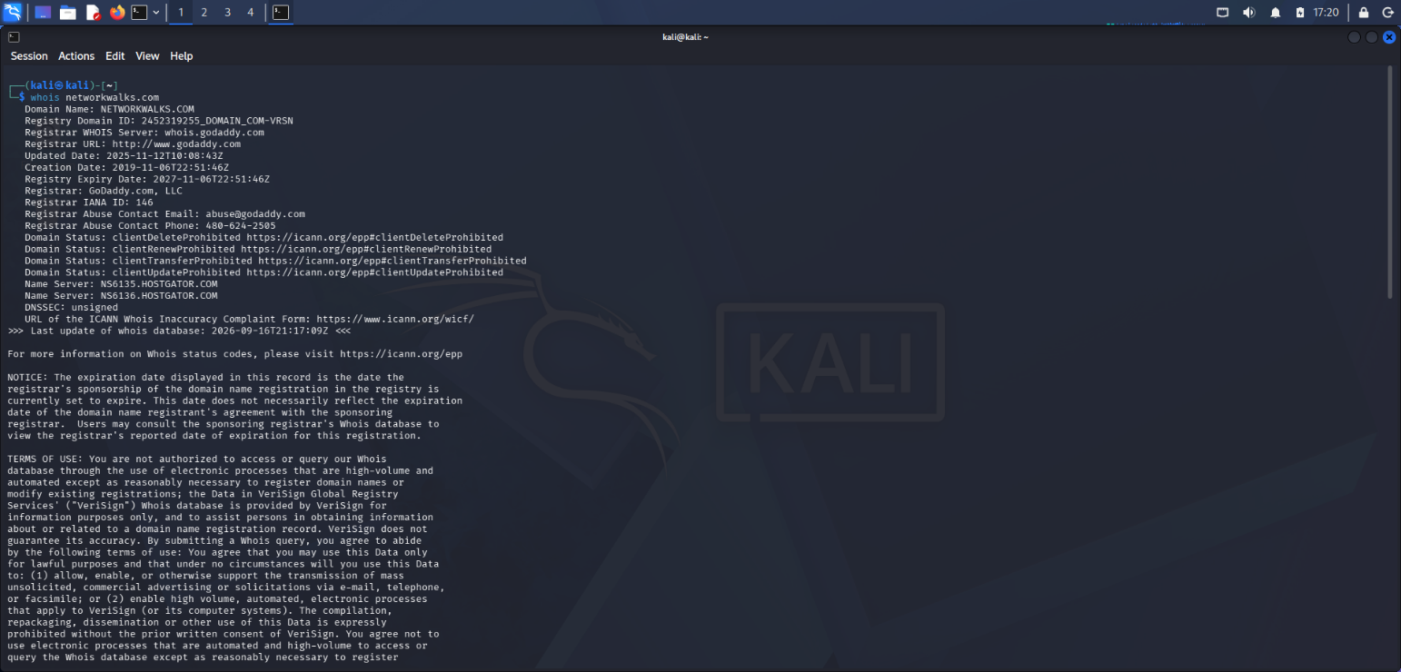

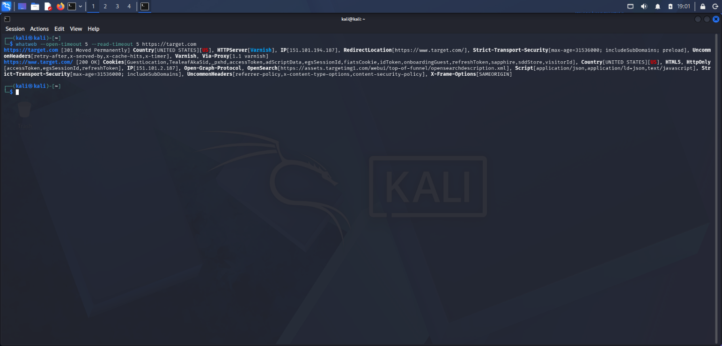

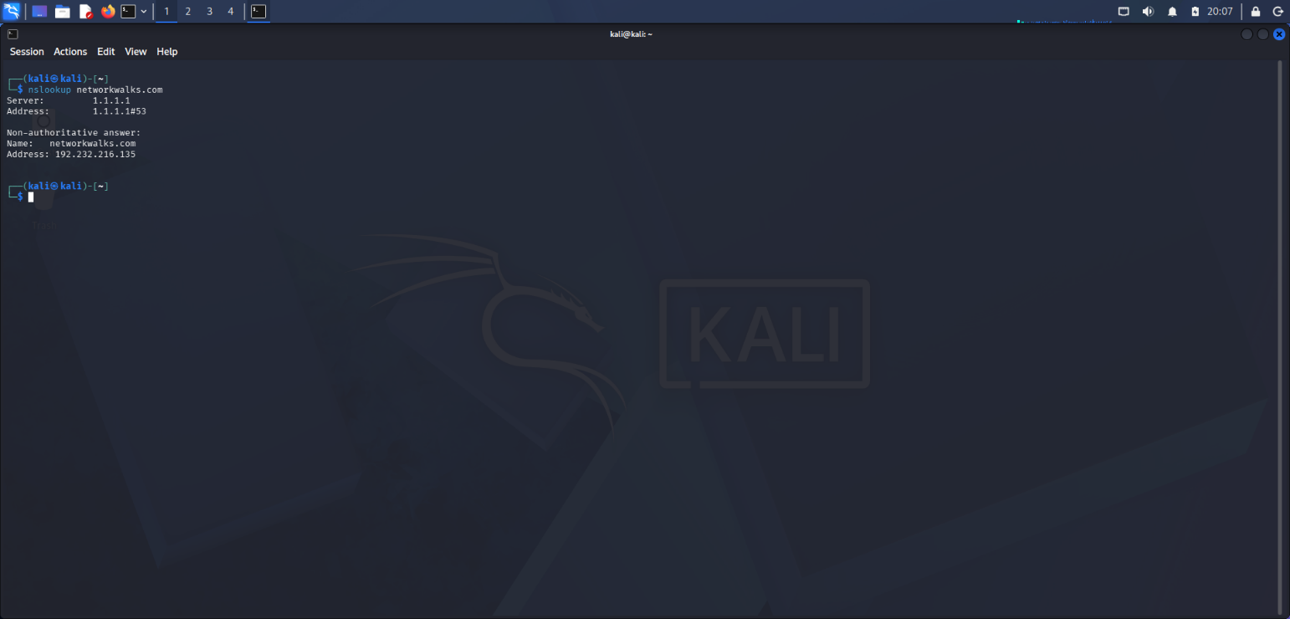

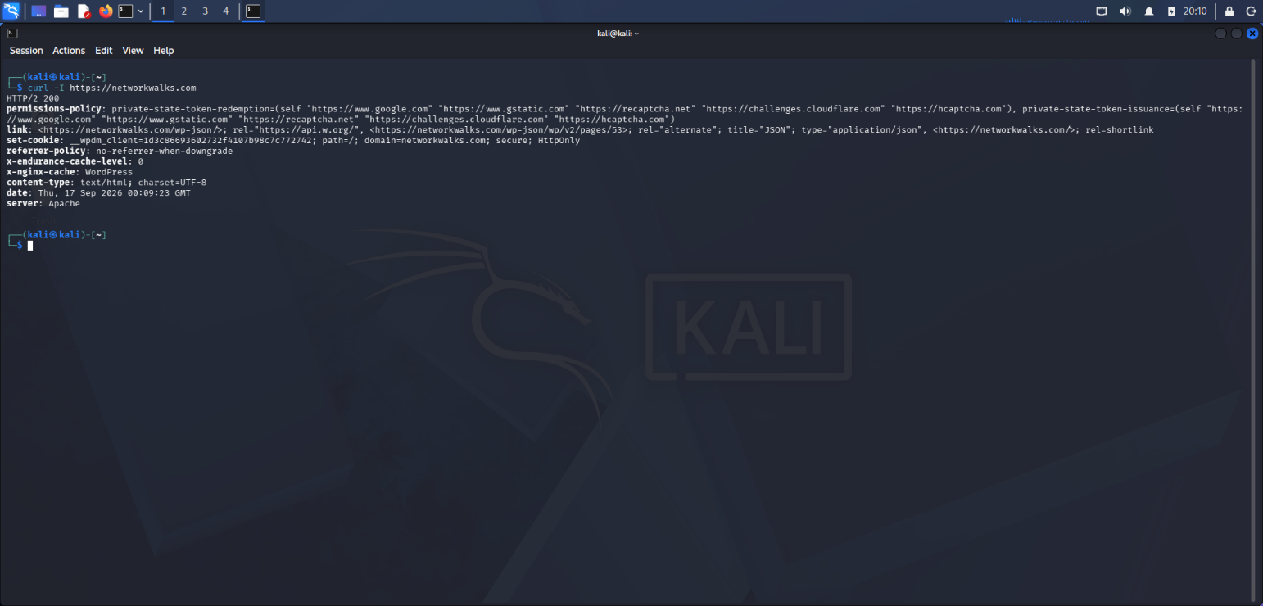

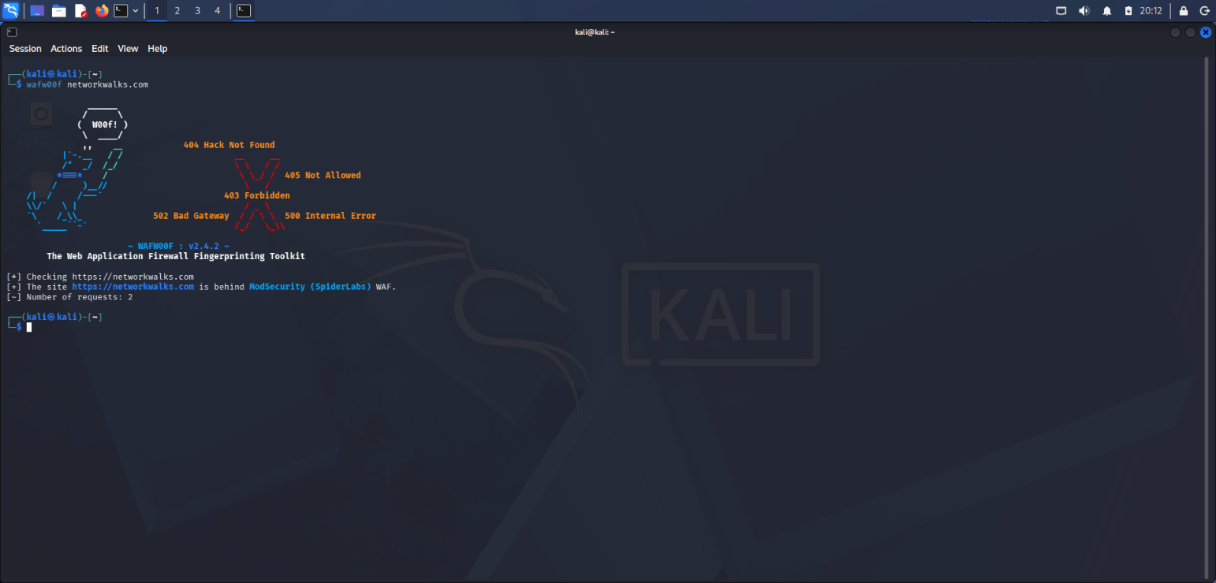

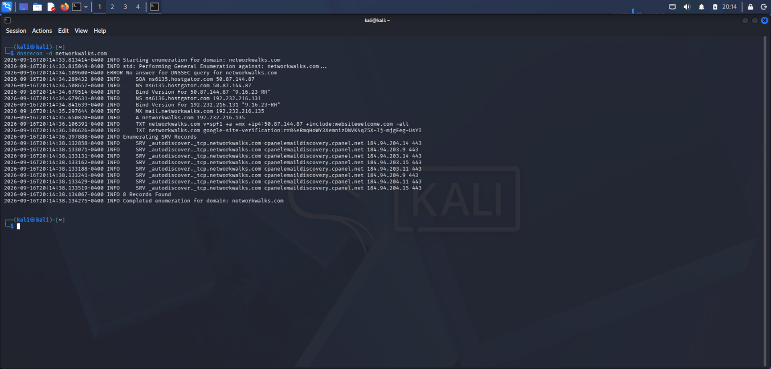

👤 Author

Kwakyewa Teming-Amoako
Cybersecurity Professional B083
LinkedIn: www.linkedin.com/in/kwakyewa-t-a0bb87418

📌 Project Information
Program Name: Cybersecurity program at Networkwalks | Week: 02 | Repository: GitHub

